**Code Challenge Project Guideline**

This is .Net Core console application with Target Framework .NET 5.0.

.Net 5.0 must be installed to run the application.

1. In order to add DI to .NET Core console application, I add ConfigureServices to the program.cs. Now class program is used for loading the configuration, and registering the services.
2. Added Class App, now run function in App.cs is equivalent to the Main in Program.cs.
3. The file appSettings.json is added for configuration settings. It includes credentials info, urls, report interval time, and other settings used in this application.
4. ITwitterServices/TwitterServices is for streaming tweets, see asynchronous function StreamTweets() which uses HttpClient to send request to / get response from Twitter REST API.
5. ICacheMemory/CacheMemory is used for saving processed data and catching data by using in-memory cache.
6. ITweetTrack/TweetTrack is used for analyzing each tweet line to get the info the assignment requested, such as average tweets per second/minute/hour, top emojis in tweets, and other info listed in the assignment. The analyzed data is saved in memory, see above CacheMemory
7. IReporting/Report is used for periodically reporting the info this assignment requested, see below the screenshot. I currently set report interval time as 10 seconds. It reports every 10 seconds. You can modify the settings in appSetting.json as you need.

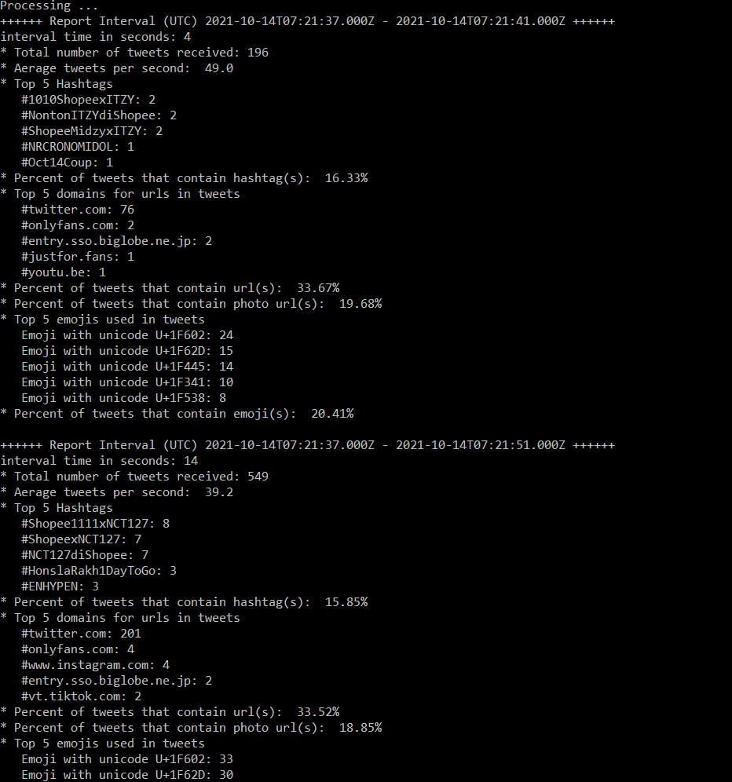

1. JHACodeChallengeTest is unit testing project which is built with xUnit. I added a couple for test cases for searching emojis in tweet. More test cases could be added in this unit testing project in the future.